Assignment No:6
Cyber Security (CEH)
Teacher Name: Mr. Salman Muhammad Aslam 30-03-2026
Assignment No: 6
Task
Create a step-by-step Lab Manual Setup document with screenshots.
Solution:
Title: Install Metasploitable 2

Objective: Install Metasploitable 2 on system (Virtual Machine/Virtual Box)

Requirements:

- Processor: 64-bit Dual/Quad -core Processor & Intel Core i3/i5/i7.
- RAM: 1GB-2GB (4–8 GB recommended for smoother operation).
- Storage: 10-20 GB HDD or SSD space (Free space).

Steps:
Step 1:
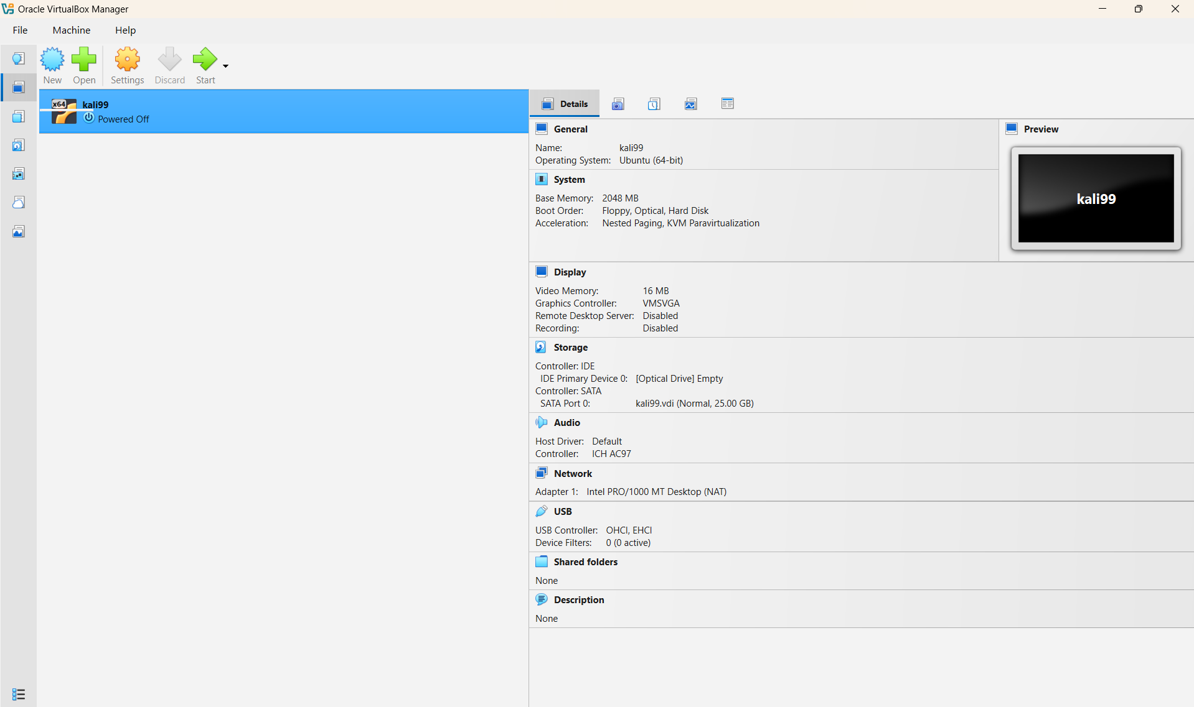
Step 2:
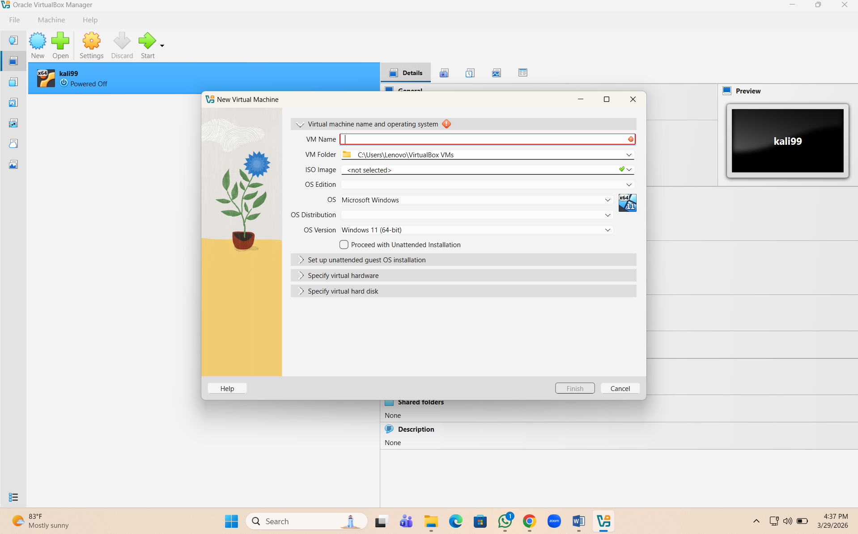
Step 3:
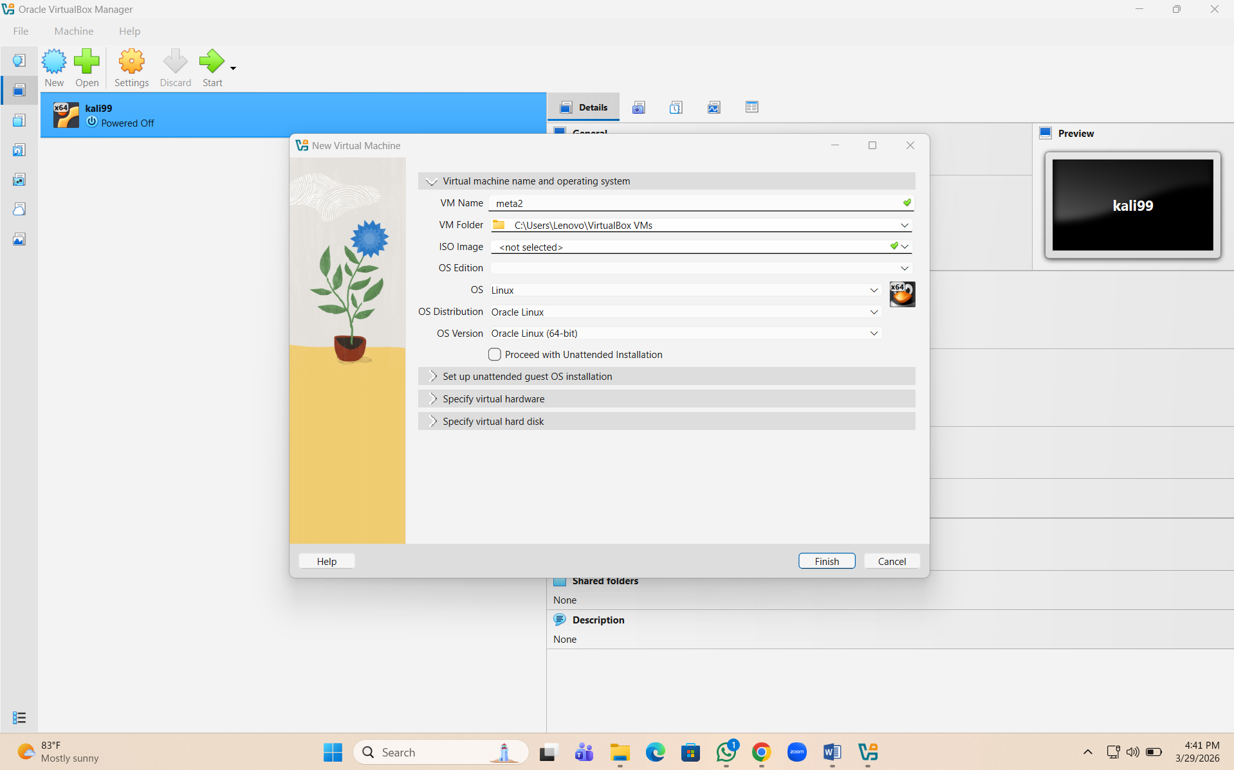
Step 4:
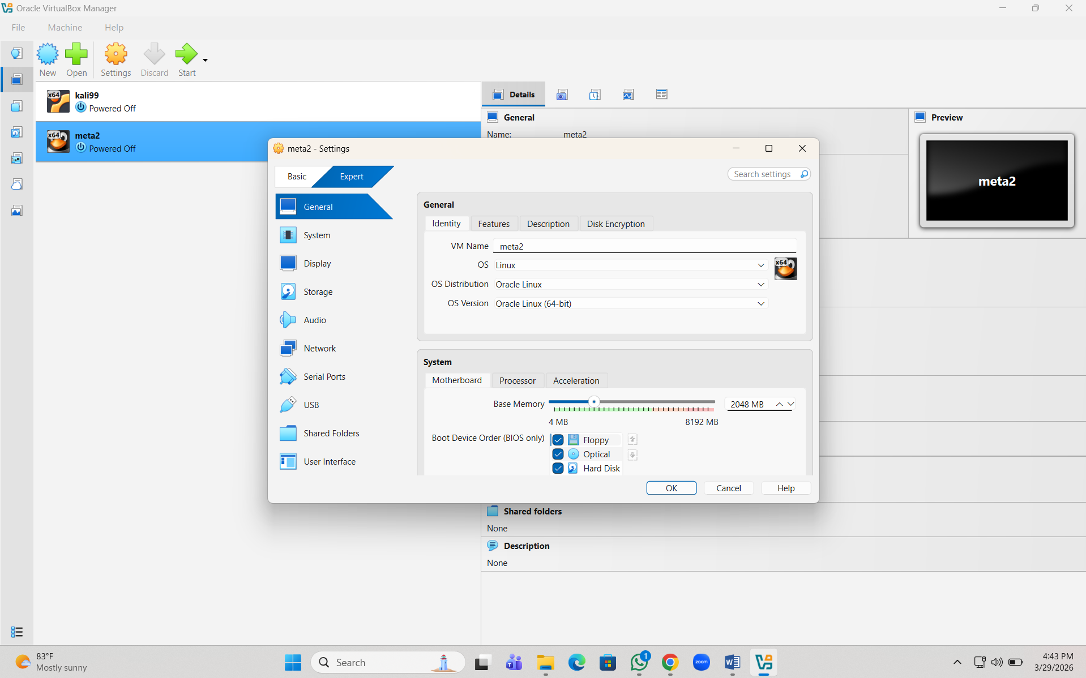
Step 5:
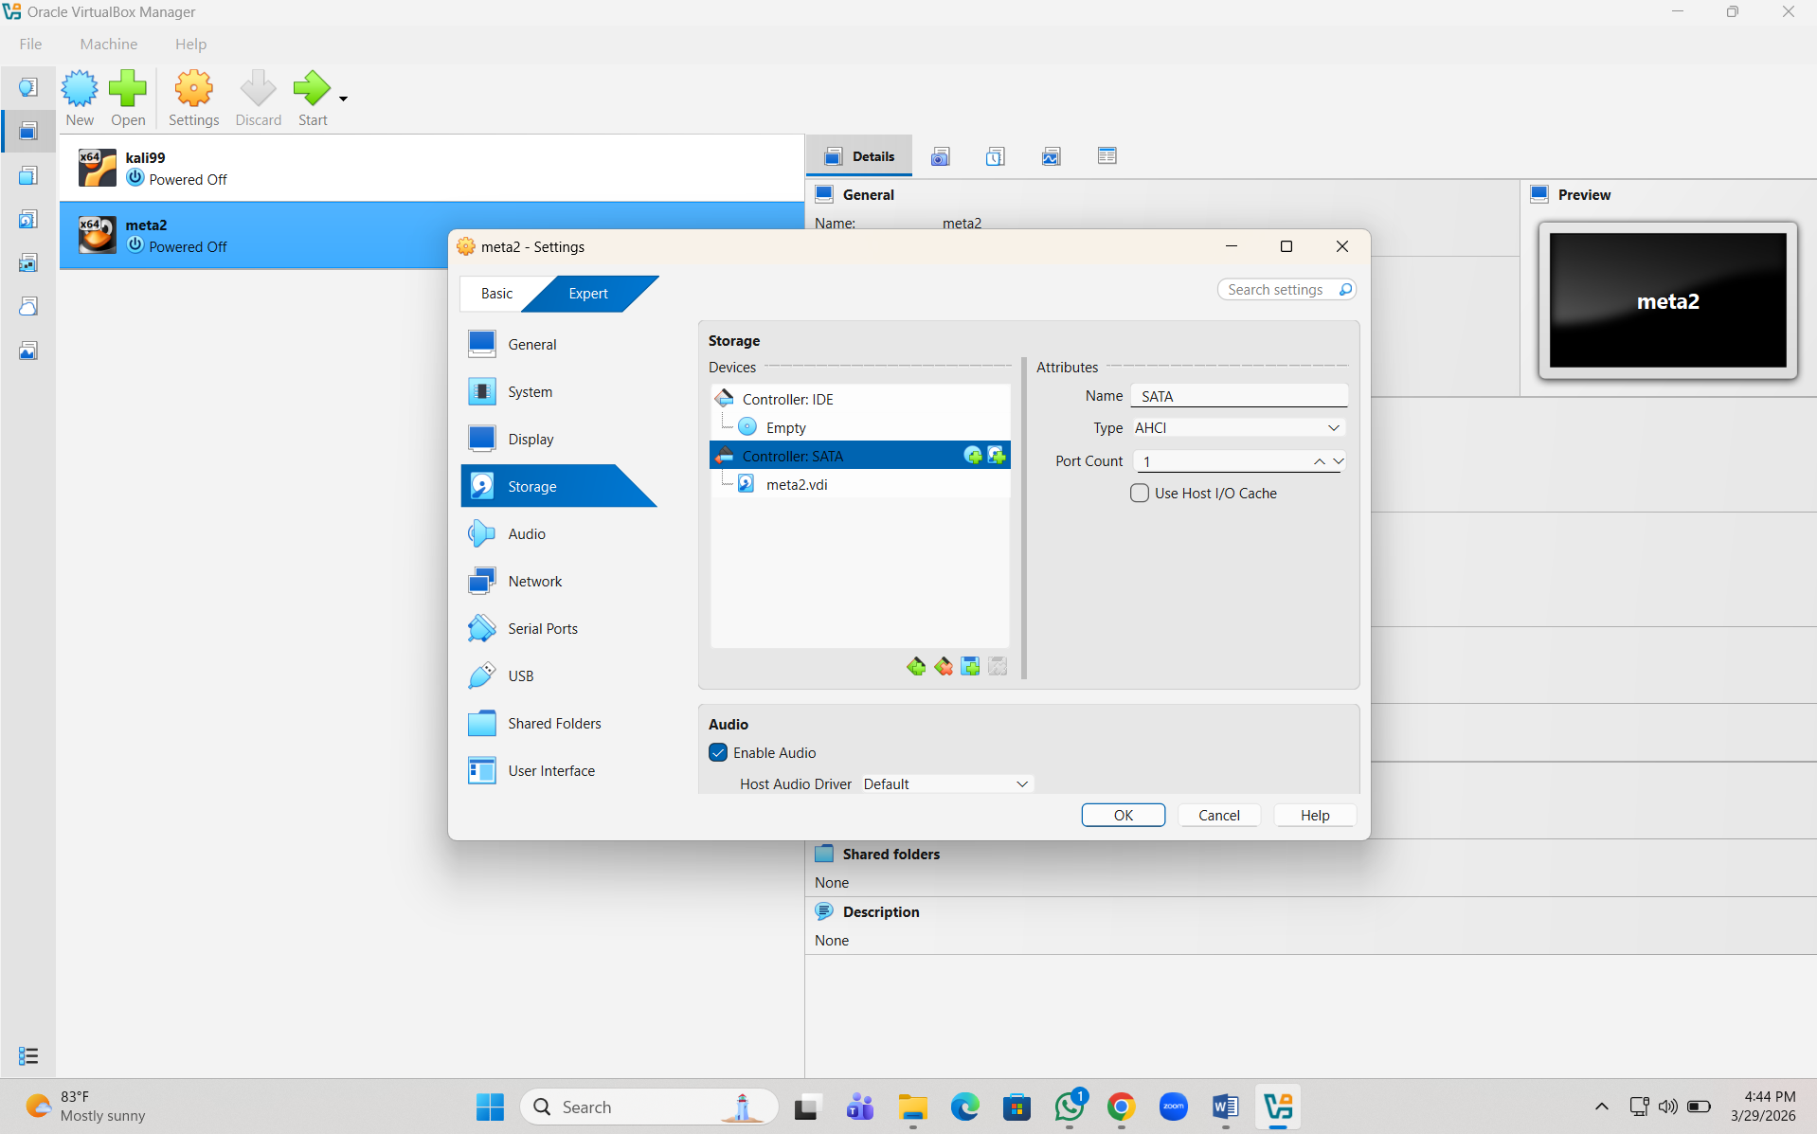
Step 6:
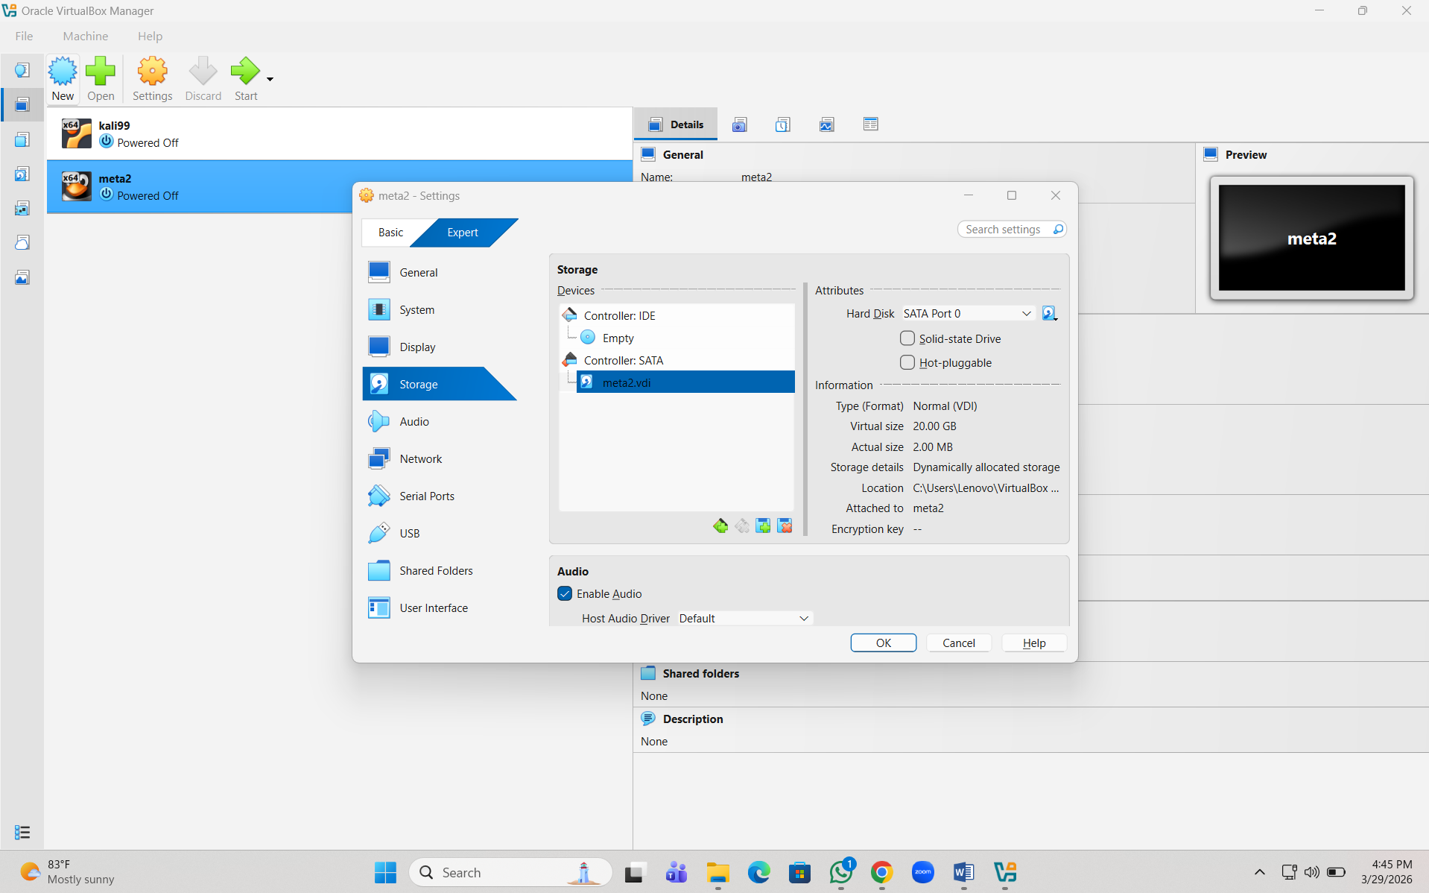
Step 7:
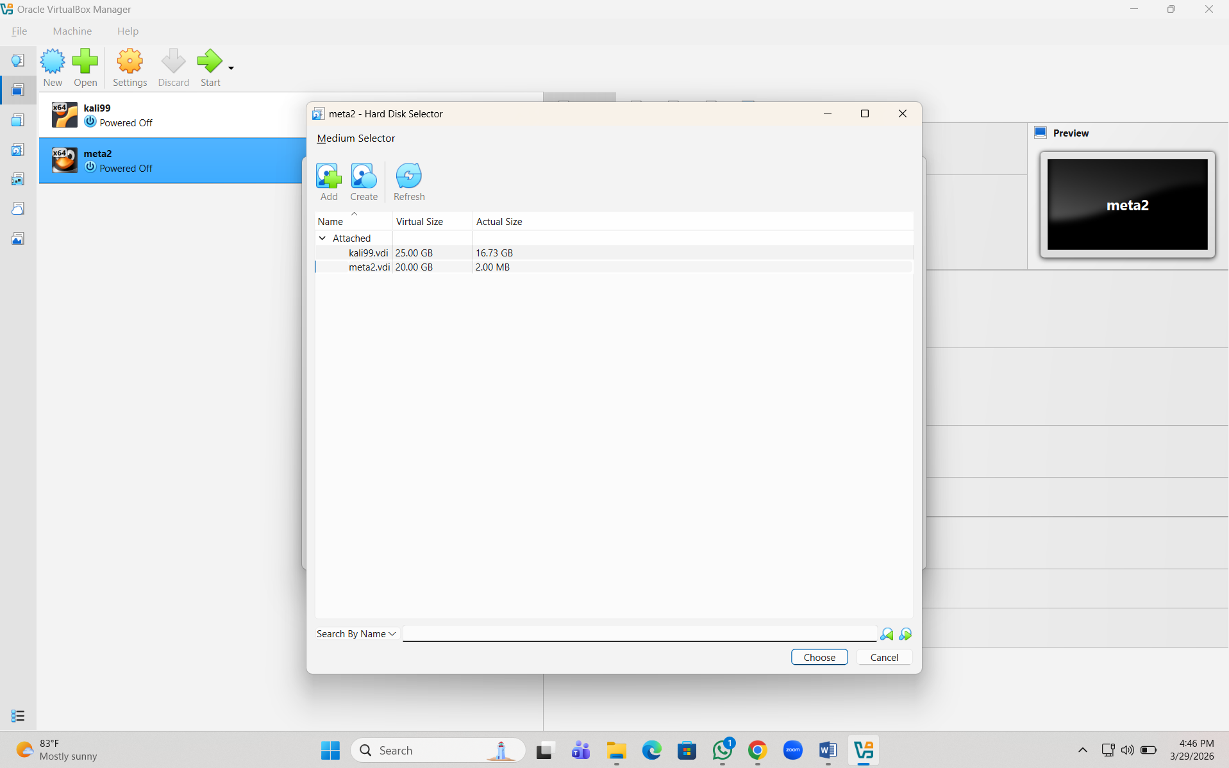
Step 8:
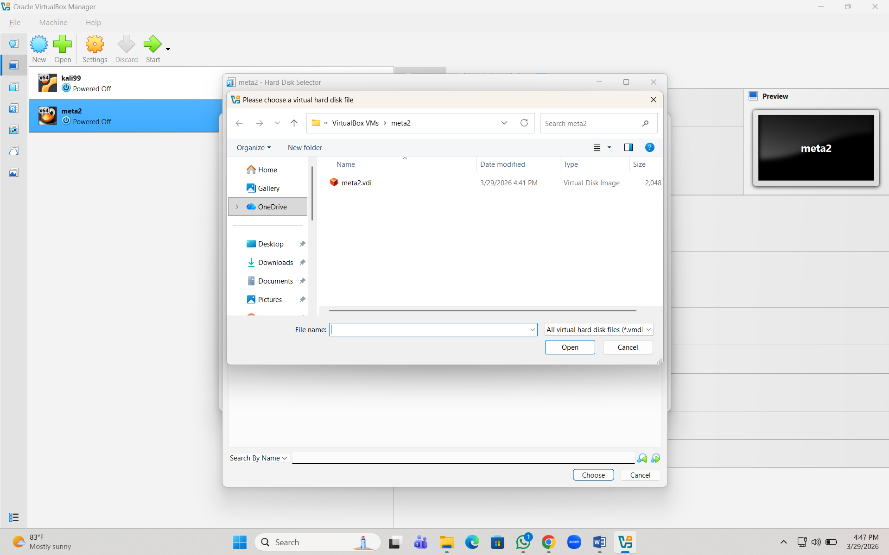
Step 9:
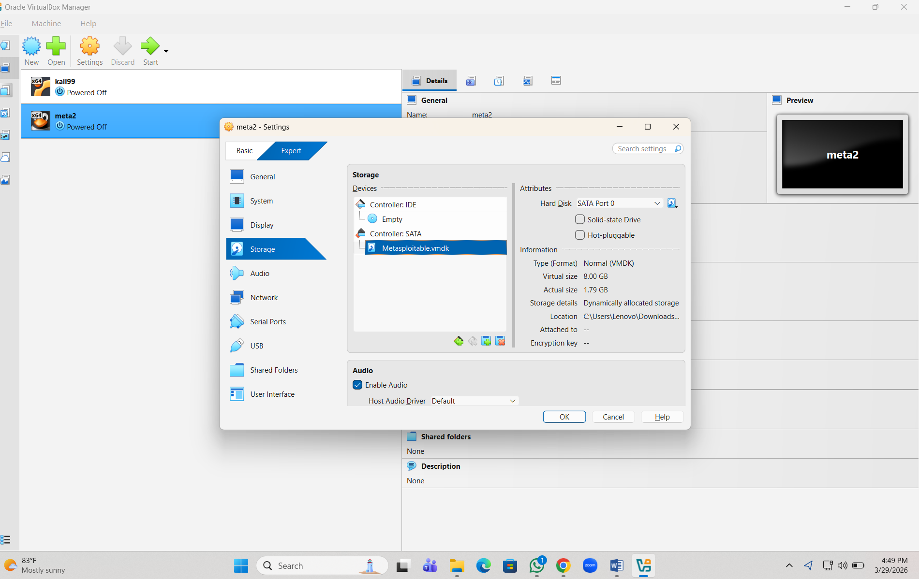
Step 10:
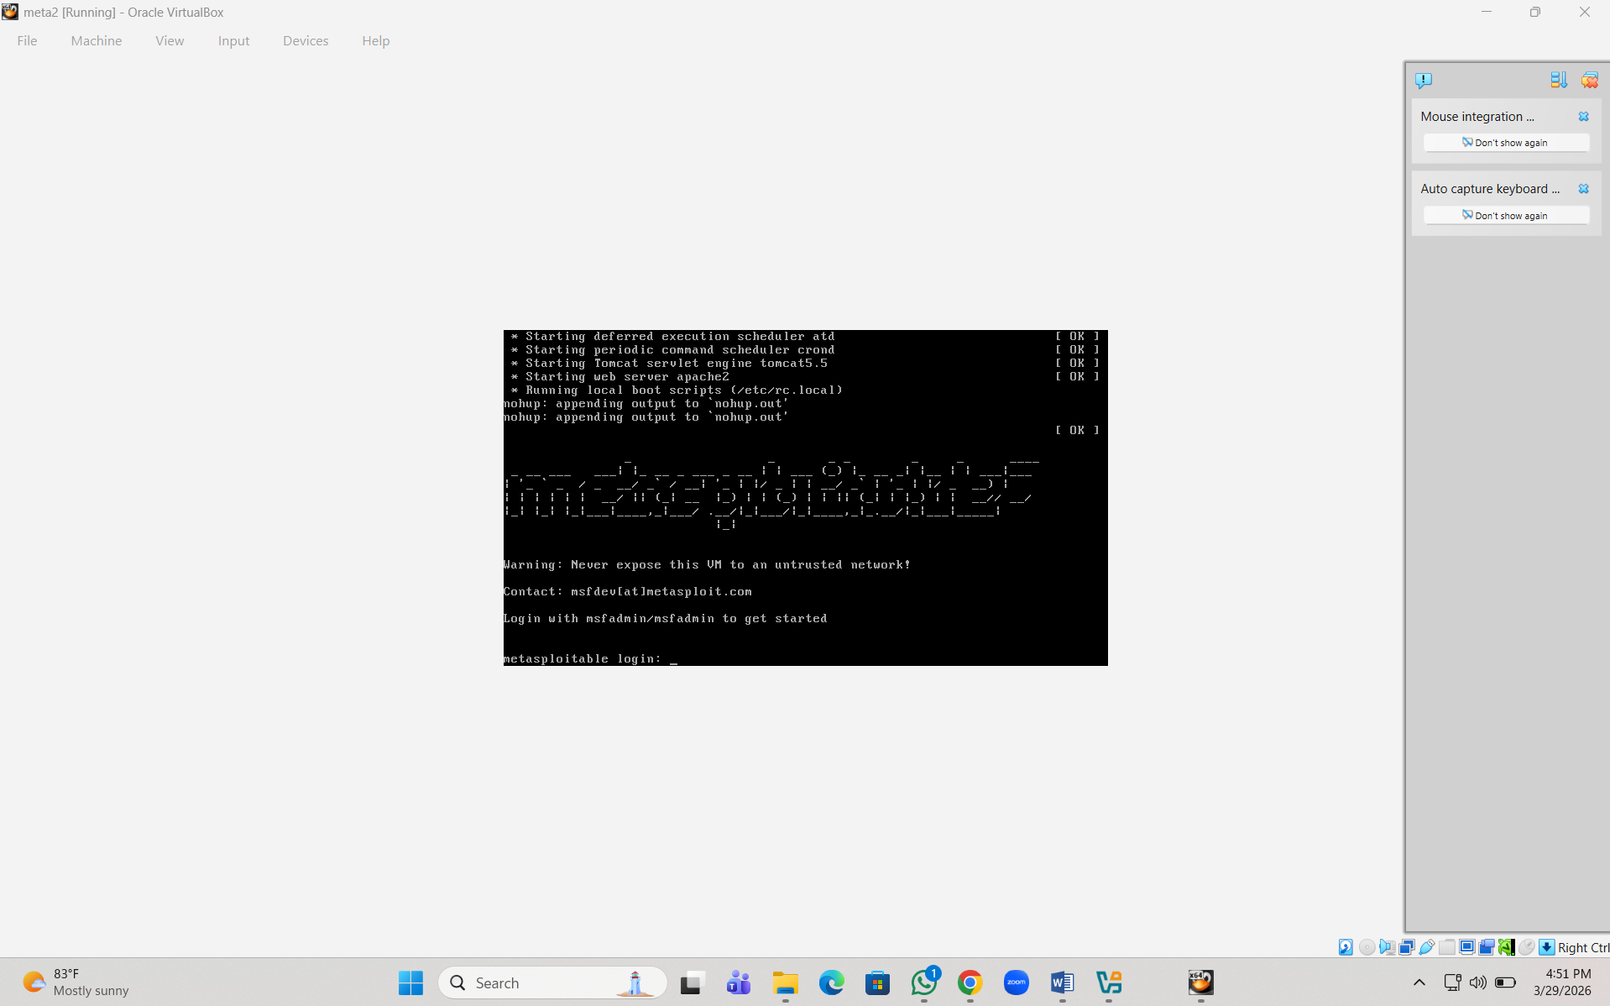
Step 11:
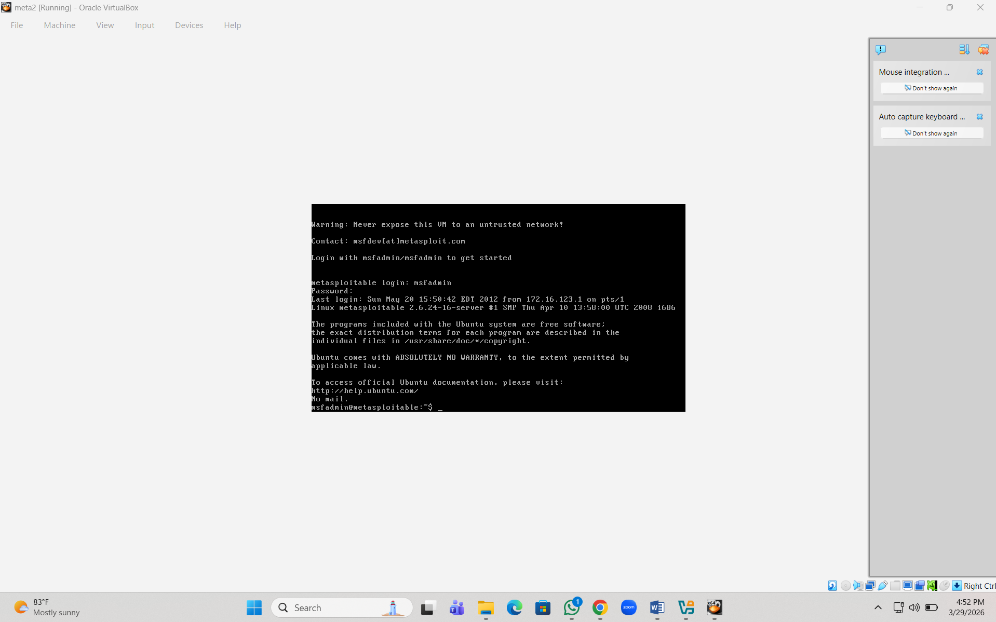
Step 12:
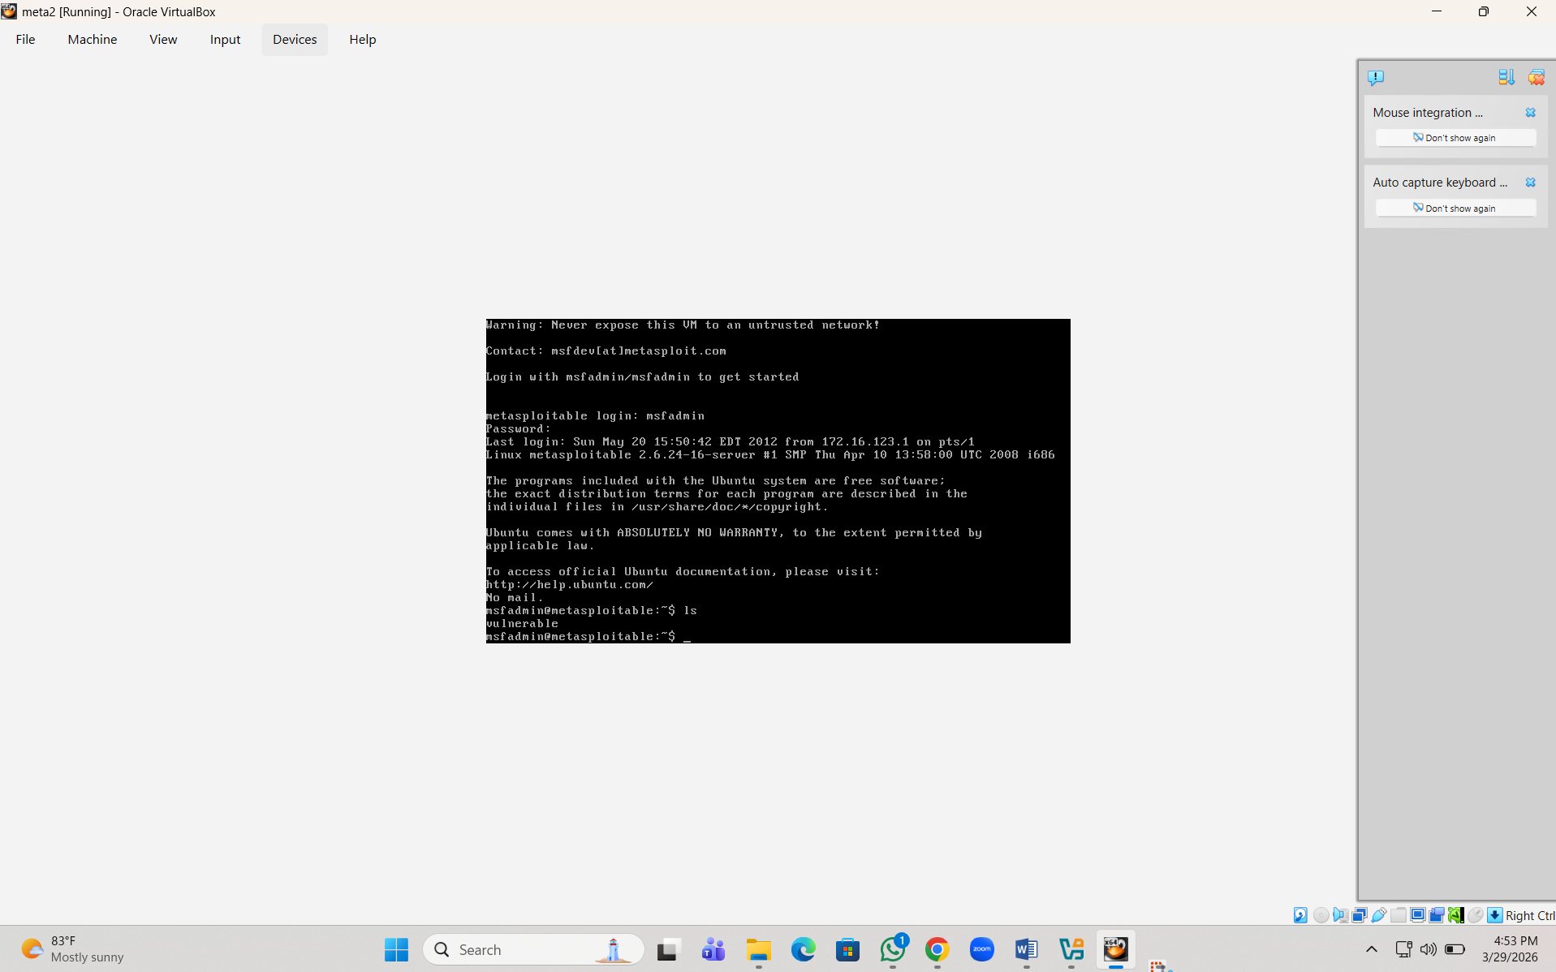
Result:
